**ELECTRONIC DEVICE FOR MEASUREMENT CONCENTRATION OF MERCURY IN THE ENVIRONMENT**

***Version 1.0***

**By: Miguel Angel Aroca Cervantes**

1. **OBJECTIVE**

Describe the electronic design of the device for measurement concentration of mercury in the environment; including its schematic, flow chart programming, download links of the Control application and other resources; and its operating manual.

1. **REACH**

To understand the operation manner of the electronic device for measurement concentration of mercury in the environment, through the study of applied physics, the different component parts and its programming; and can easily replicate this tool.

1. **DESIGN SPECIFICATIONS:**

The tool has 3 sections:

* + - * The electronic measurement device.
      * An Android App which is the user interface.
      * And a web database.

**3.1. Electronic measurement device:**

It is responsible for measuring mercury levels in the environment and display them on a built-in screen, or through a user interface (Android app); which also it can be controlled.

The device has the following parts (Figure 1. Schematic interconnection is shown):

* 5 sensors with electric output signal based on a phototransistor, whereby the amount of mercury (Hg) is measured by the transmittance obtained by passing a light beam by a specific sample.
* An embedded system (Arduino pro mini) that converts the measured analog signal to digital to display it on a LCD screen or to encode it and then send it via serial communication to a wireless communication module.
* An LCD display that allows direct visualization of the measures taken by the sensor.
* A Bluetooth module (HC 06) that allows wireless communication between the measurement device and the user interface for the management from the application.
* Buttons, to operate the device without the application.
* 3.6V@750mAh Battery for powering the device.

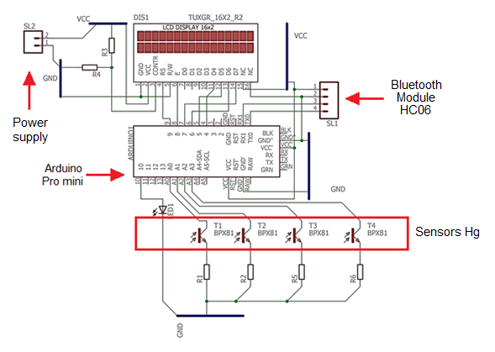

Fig1. Schematic Measurement Electronic Device.

The detail of each part of the device and its operation mode are shown in Section 4, Operation Manual.

**3.1.1. Flowchart measurement electronic device:**

The code lines programmed in the IDE from Arduino obey the following flow chart (Figure 2 a, b, c and d). By the following link you can access the source code, [fealac.uniandes.edu.co](https://cmua.uniandes.edu.co/)

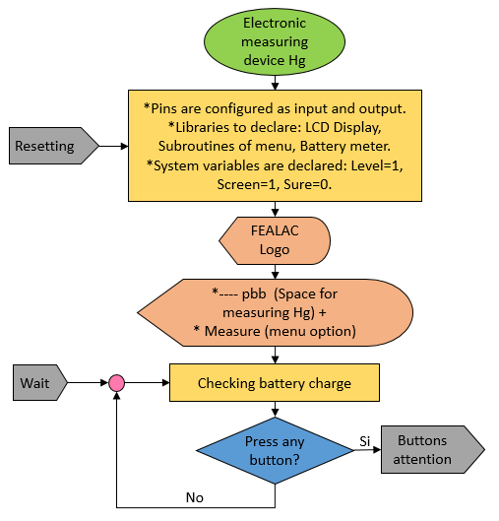

Fig2 (a). Code flowchart loaded Arduino

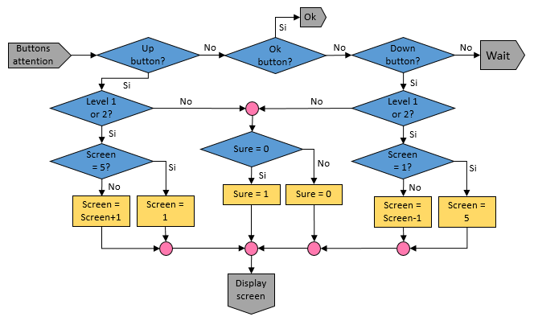

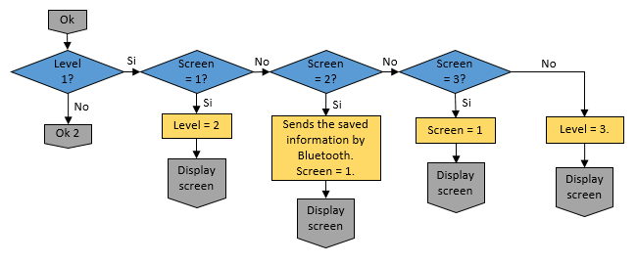

Fig2 (b). Code flowchart loaded Arduino

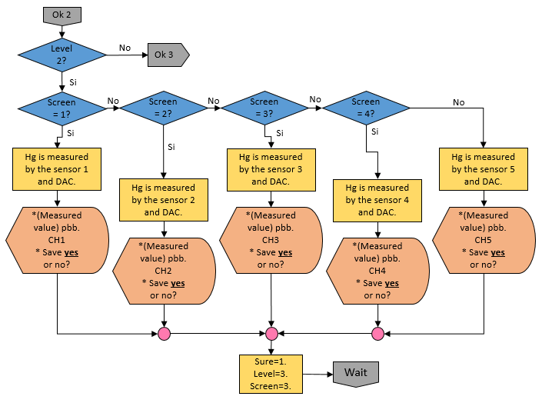

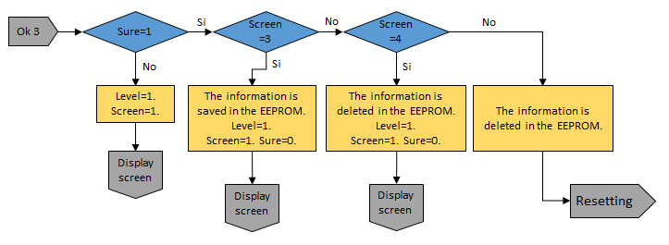

Fig2 (c). Code flowchart loaded Arduino

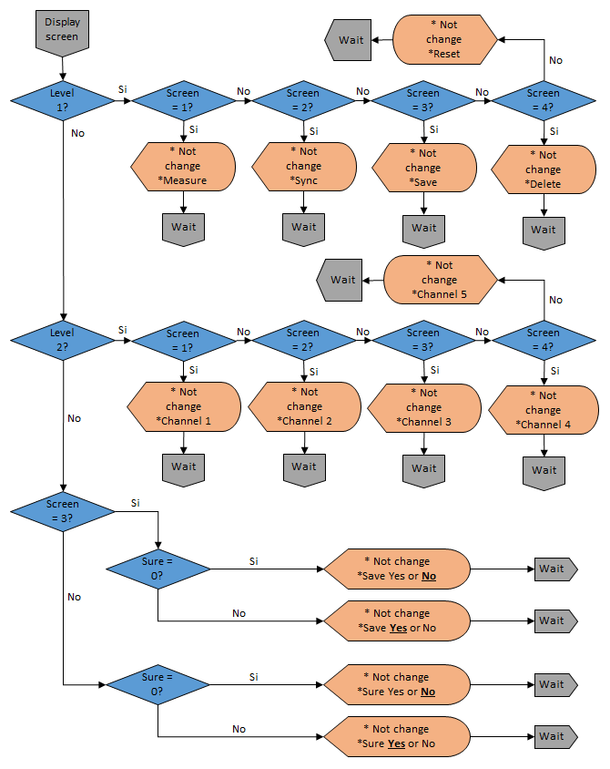

Fig2 (d). Code flowchart loaded Arduino

**3.2. Android App:**

It is the user interface for mobile where all the information sent by the measurement electronic device is compiled, to be reviewed and analyzed by the end user. Also from this application you can operate the device.

Programming is for Android 5.0 or higher. The interface has basically two screens; the main screen and the registration screen. By the following link you can access the source code, [fealac.uniandes.edu.co](https://cmua.uniandes.edu.co/)

The graphical structure of the main screen consists of the following elements:

* On the top:
  + TextView 1: Displays the App name.
  + TextView 2: Displays the variable name to be measured
  + ProgressBar: Displays in a bar the mercury concentration.
  + TextView 3: Displays an equivalent number to the mercury amount in units ppb (parts per billion).
  + ImageView: Displays the organization logo
* On the bottom:
  + Connect Button: Allows matched by Bluetooth technology the cellphone with the measurement device.
  + Measure Button: Takes the captured information by the measurement equipment and displays it on the phone screen in TextView 3 and ProgressBar

The following figure shows each of the parts of the main screen (Figure 3).

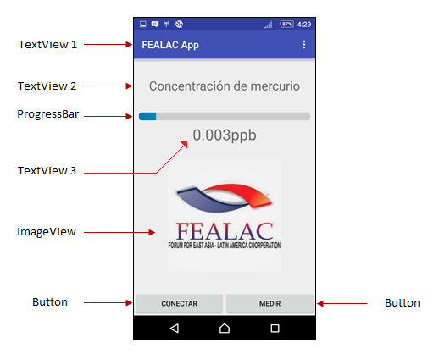

Fig3. Main screen distribution.

The graphical structure of the Registration screen has the following elements:

* On the top:
  + ListView: Display a measurements list.
* On the bottom:
  + *Synchronize* Button*: Updates on the Internet information*.
  + *Delete* Button*: Deletes the data from cellphone*.

The following figure shows each of the parts of the registration screen (Figure 4).

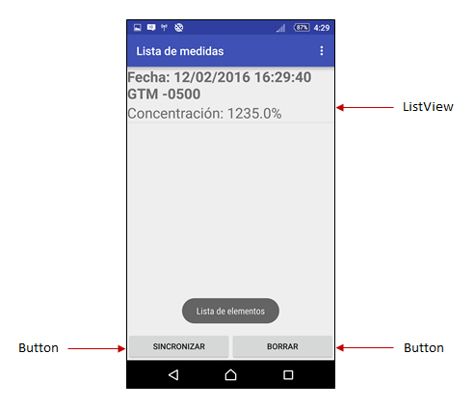

Fig4. Registration screen distribution.

**3.3. Web Database:**

They are a series of codes that allow you to save on Internet, all data collected by the device, including date, time and time zone.

This programming language is SQL, and hosted on the MySQL Server. By the following link you can access the source code, [fealac.uniandes.edu.co](https://cmua.uniandes.edu.co/)

1. **C:\Users\MAAC\Desktop\IMAGENES PC8000\chema.jpegOPERATION MANUAL:**

**WARNINGS:**

* Please read carefully this user manual before using the product. Follow all instructions and recommendations included in this document. Any use of the product that is contrary to the instructions provided in this document may cause poor performance, damage or destruction of the product.
* The manufacturer is not responsible for damages incurred as a result of other use different than included in this document, inappropriate application and disobedience of the recommendations and warnings.
* Any use or connection of products other than those included in this document will be considered undue and the manufacturer is not responsible for those consequences by these faults.
* By other hand, the manufacturer is not responsible for any damage or destruction of the product incurred as a result of improper placement, installation of components and / or operation and misuse of the product.
* The manufacturer does not take responsibility for any malfunction, damage or destruction of the product caused by the replacement of parts or components due to the use of parts or components of reproduction.
* Only expose the sensor to direct contact with water or general sample for analysis (review Section 4.1 "verification accessories" and section 4.2 "Procedure". Do not expose other electronic parts in contact with water.

**4.1. Verification of device accessories and applications:**

* + - * Electronic measurement device
      * Android App
      * Database
      * Charger

**4.1.1. Electronic measurement device:**

It measures mercury levels in the environment through sensors, and displays it on a built-in screen or via user interface (Android App); which also it can be controlled. Figure 5a and 5b. The parts of the device are shown.

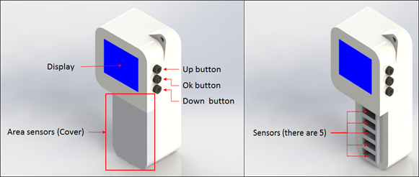

Fig5 (a). External parts of the electronic measurement device.

* Display: Allows direct visualization of the measures taken by each of the sensors.
* Up button: Moves to the options menu, choose the sensor or channel to be measured, or choose to accept or cancel an operation; all in a rising way.
* Down Button: Navigates in the options menu, choose the sensor or channel to be measured, or choose to accept or cancel an operation; all in a descending way.
* Ok button: After pressing the function of the option displayed on screen is performed.
* Sensors: There are five sensors in total, by those sensors the mercury amount (Hg) is measured in a specific sample.
* Cover: Protect the sensor area when the device is not being used.

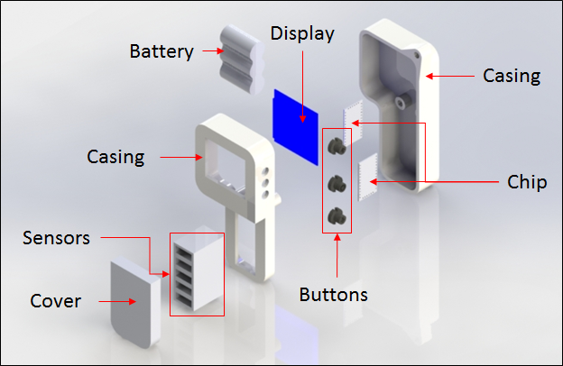

Fig5 (b). External and internal parts of the electronic measurement device.

**4.1.2. Android App:**

chemaAllows you to control the device from a mobile application, collects all the information sent by the electronic measurement device, to be reviewed and analyzed by the end user. In Figure 6a and 6b. The structure of the application are shown.

This app is compatible with Android 5.0 or higher.

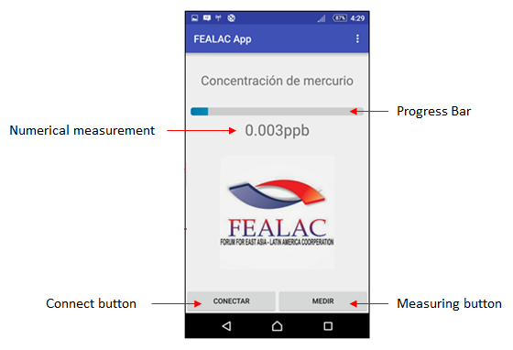

Fig6 (a). Main screen parts.

* Progress Bar: Displays the mercury concentration relative.
* Numerical measurement: Shows the amount of mercury in ppb units (parts per billion).
* Connect button: Allows to match by Bluetooth technology the cellphone with the measurement device.
* Measurement button: Takes information captured by the measuring equipment and displays it on the screen of the cellphone (in the progress bar and in the numerical measurement area).

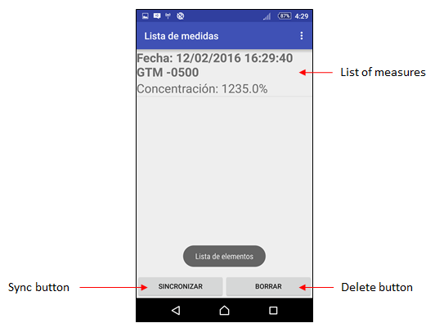

Fig6 (a). Register screen parts.

* List of measures: Display a list of measurements including date, time and time zone.
* Sync button: Updates the measurement information in the database on the Internet.
* Delete button: Delete the data measurements stored in the cellphone.

**4.1.3. Database:**

It is a web space to store the information of the measures taken by the device and then recover them anywhere with Internet access. To access the database follow the link [fealac.uniandes.edu.co](https://cmua.uniandes.edu.co/)

**4.1.4. Charger:**

Allows to set the battery charge for using the device. It is not necessary to extract the battery for charging it. Be sure to check the charge level on the screen of the device before use.

**4.2. Procedure:**

**4.2.1. Measurement and control from the electronic measurement device:**

The device has an intuitive mode operation. This section describes the menu options and the steps to measure Hg in a specific sample are given.

Menu options:

* Measure: Allows to measure the quantity of Hg from the sample
* Sync: Enables Bluetooth connection to control from the application.
* Save: Saves a record on the device of the measures taken. If not previously taken a measure, the Save option will take you to the Measure option.
* Delete: Deletes all the information saved.
* Reset: Resets the device configuration.

Note: Use the arrow keys to scroll up and down in the menu options, and the OK button to access any of them.

Display layout:

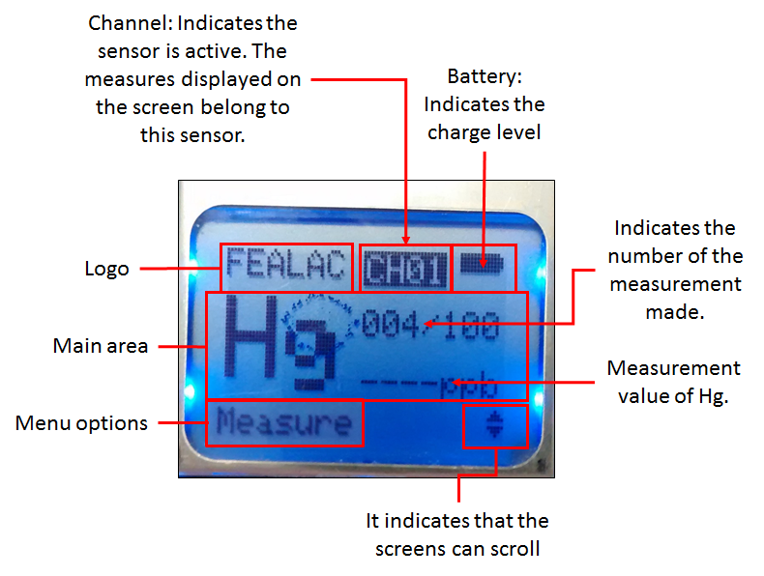

By measuring Mercury:

1. Turn on the device. FEALAC logo appears and then load the main screen.

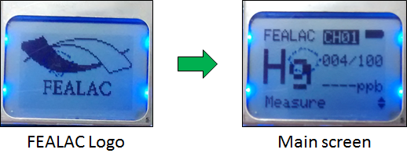

1. Press the OK button while the Measure option is on the screen. This appears by default after loading the logo FEALAC, if this option does not appear, use the up or down keys to locate.

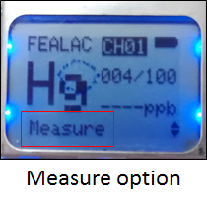

1. Display a signal indicating at the bottom screen the channel or sensor that will measure. Use the up or down keys to change the channel and then press OK to take the measurement.

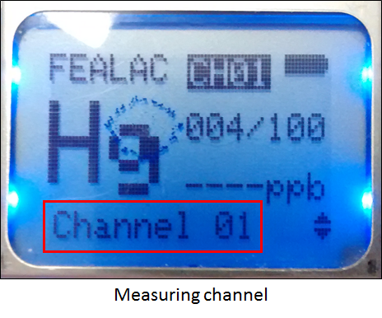

1. The measure appears on the screen with the option to save it. If you want to store the information press the OK button, otherwise scroll in the other menu options.

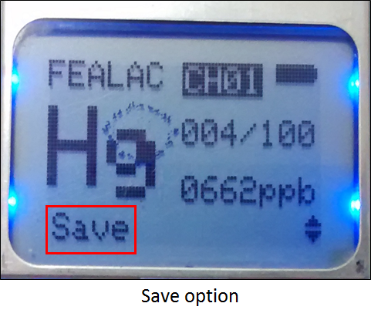

To delete:

1. Go to Delete option from menu y press Ok.

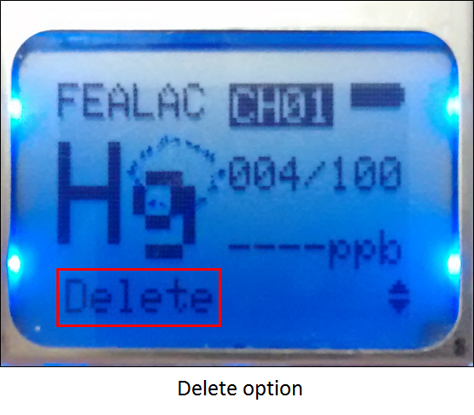

1. A confirmation screen appears, if you press the OK button while the option selected is "Yes", so you will erase the information stored on the device. If you press the OK button while the "No" option is selected on the screen that process will cancel the option.

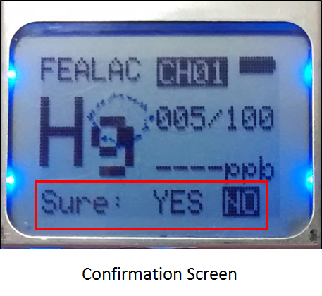

Note: The Reset option works in a similar way to the Delete option, the difference is that this option not only erase the stored information, also restores the initial configuration.

**4.2.2. Measurement and control from the Android app:**

To control from the Android App, once downloaded the application from the link [fealac.uniandes.edu.co](https://cmua.uniandes.edu.co/) and installed on a mobile device, follow these steps:

1. Turn on the measuring device.
2. Go to the Sync option and press OK.

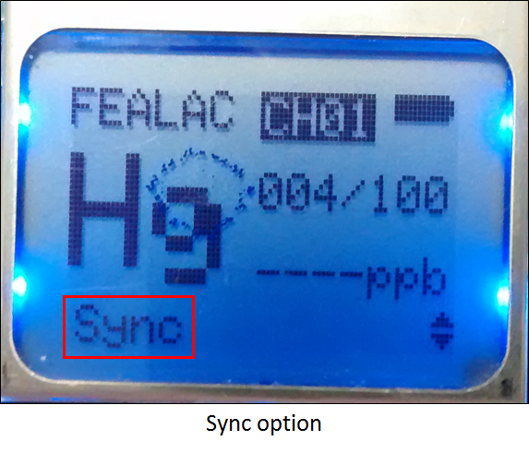

1. In the application press the Connect button and wait until the devices are matched. Once matched follow the instructions and help in the mobile.
2. **EXCHANGE CONTROL:**

|  |  |  |  |
| --- | --- | --- | --- |
| **EXCHANGE DESCRIPTION** | **DATE** | **VERSION** | **APPROVED BY** |
|  |  |  |  |